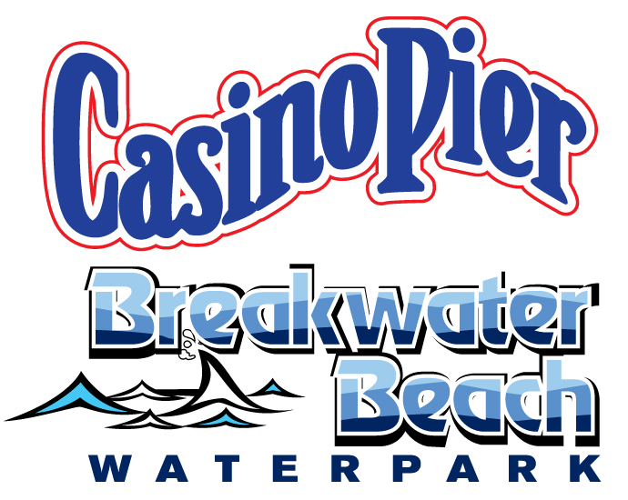
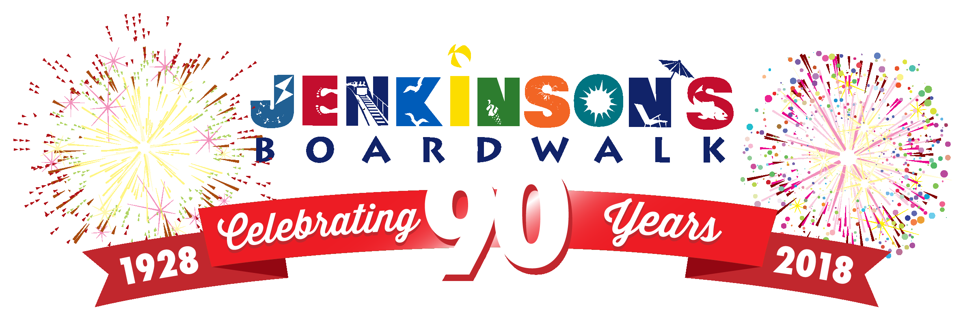
The Storino family is extremely honored and humbled to be recognized by Fulfill of Monmouth and Ocean Counties as one of the 2018 Fulfill Gala Honorees. We would like to also congratulate our fellow honoree, Jim Vaccaro and Manasquan Bank, who have been serving our local communities since 1874. Both Jenkinson’s Boardwalk in Point Pleasant Beach, and Casino Pier and Breakwater Beach in Seaside Heights have been providing countless memories and smiles that families have cherished for generations - whether it be relaxing during a perfect beach day, enjoying classic boardwalk foods such as salt water taffy and pizza, enjoying one of our amusement parks, or just taking a nice stroll down the boardwalk, there is fun for everyone.

For over 40 years, we pride ourselves on being fortunate enough to give back to our local Jersey Shore communities and organizations, and have considered it a privilege to work with Fulfill in that time. Although we have made numerous financial contributions over the years, it is the special projects we have collaborated on that have been the most rewarding. One of our first projects, a partnership with several Ocean County businesses, was the Summer Lovin’ discount card for which all profits went to Fulfill. Our most recent project has been to raise not only funds, but also awareness, for the childhood hunger initiative during our annual Easter sales at both Jenkinson’s and Casino Pier/ Breakwater Beach. These projects have allowed us to work with Fulfill and gain a greater understanding of everything they offer the community.

Jenkinson’s Boardwalk was founded in Point Pleasant Beach in 1928 by Charles Jenkinson. It originated as a large open-air pavilion which featured a candy shop, soda fountain, refreshment stand, and large salt water swimming pool. In 1976, The Storino family purchased Jenkinson's Boardwalk and all of its assets from the Jenkinson’s family. Over the years, it vastly expanded to include beaches, an amusement park, aquarium, arcades, and much more. In 2002, the Storino family also purchased Casino Pier and Water Works (now named Breakwater Beach) in Seaside Heights. About ten years later, Casino Pier suffered significant damage from the effects of Superstorm Sandy, losing over 200′ of its’ northernmost section as well as several rides which were lost in the Atlantic Ocean, including our famous Jet Star roller coaster. Over the next five years, we have completely rebuilt and expanded our pier over the beach on the north end, and included brand new attractions such as the Hyrdus roller coaster and a 141’ Ferris Wheel.

Now in our third generation of ownership, we look forward to continue to serve our communities and our working relationship with Fulfill of Monmouth and Ocean Counties to help give back to those who are most in need.

