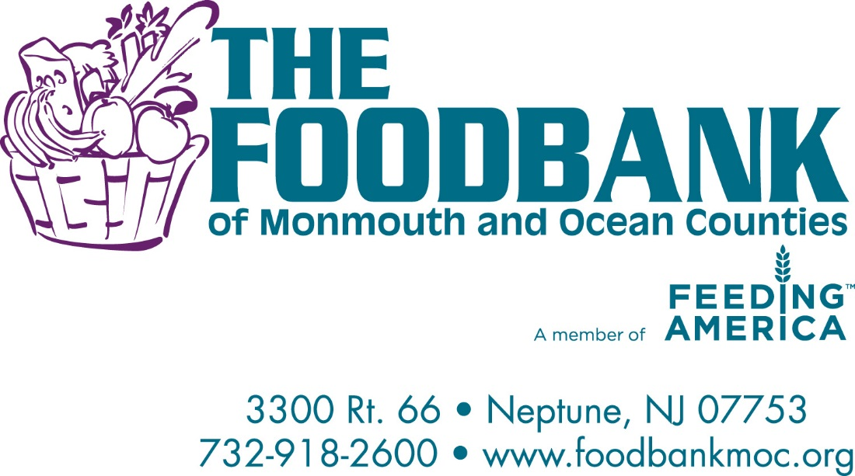
Good Manufacturing Practices (GMP) Program

The FoodBank of Monmouth & Ocean Counties methods, practices and controls used in the distribution of high quality products will be such that all of our products will be received, processed, held, and shipped in accordance with our Prerequisite and Food Safety Program.
The FoodBank of Monmouth & Ocean Counties has developed the following Good Manufacturing Practices (GMPs) to support this requirement.
Please always keep in mind that we are all required to do our part to provide our customers with safe and wholesome product. The following should be considered the minimum acceptable standards for our Operations. Use good judgment whenever you are in this position of trust and remember to put safety and quality of the product foremost during all of your activities.
These requirements apply to all employees, volunteers, and visitors entering or working in the facility, including temporary personnel and contractors. These rules are applicable at all times, including downtime, weekends and holidays. Employees, volunteers, visitors, and contractors must wear a badge identifying who they are at all times while in the Operations.
Please familiarize yourself with these requirements. Help us maintain the highest quality and food safety standards.

GMP Requirements:
Appearance
No open –toed shoes will be worn.
No clothing with profanity and/or explicit graphics will be worn.

Personal Habits
Persons having open sores, complaining of illness, or infected with a communicable disease are not allowed to work in areas where product may become contaminated.
Persons may not walk, sit or climb on raw materials, finished product or product packaging.
Hands MUST be washed after using the restroom, before entering the Operations, or after touching any unsanitary surface. Disposable gloves are required to be changed; this especially includes when working with the Big 8 Allergens: Milk, Eggs, Wheat, Soy, Peanuts, Tree Nuts, Shellfish, and Seafood.
Use of Food, Beverages, and Tobacco
Food and Beverages shall not be consumed in the warehouse, sort room, or any food distribution areas other than in the designated break or lunch areas.
Smoking is ONLY permitted in the designated smoking area located outside the facility.
Smoking materials shall not be stored in any area other than the designated locker area.
General Requirements
Consumption of product is not permitted.
Doors and bay doors opening to the outside will be closed properly and opened only when necessary to perform warehouse activities, such as taking out trash, loading trucks, etc.
Employees and volunteers must report to the Senior Operations Supervisor (or person in charge) the presence of insects, rodents, unsafe conditions, fire hazards, or anything else that might jeopardize the sanitation and safety of merchandise or personnel in the warehouse. Cell phone use is not permitted in the Operations.
Thank you for your cooperation and compliance. Together we can ensure our customers safe and wholesome product.
Name (Printed)___________________________________________________
Signature________________________________________________________
Agency_________________________________________________________

