September is Hunger Action Month
30 Ways in 30 Days — Together We Can Solve Hunger

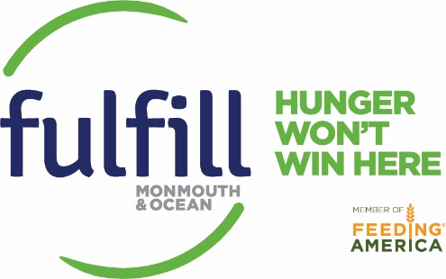

SEPTEMBER 2017

Sun | Mon | Tue | Wed | Thu | Fri | Sat
 |  | Spread the Word post a 30 Ways in 30  Days Calendar on  the office fridge | 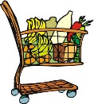  Check out Hunger Volunteer for the campaign or scan a coupon at your local grocery store this  fall | Join Our Team!  Become a Food- Bank volunteer today! | 1  Find Fulfill on Face- book and “Like” us. Then ask your friends to like us too! | 2  Wear orange to show your support and raise awareness for hunger action month!
3  Garage Sale:  Organize a neighborhood garage sale & donate 10 % of the proceeds | 4  Share A Meal with loved ones While cooking and eating, discuss  the importance of fighting hunger. | 5  Hunger Action  Family Day! S.O.S Food Drive | 6  Brown Bag Benefit: Ask co-workers to bag lunches next week, and donate money saved to Fulfill | 7  Foodless Food Drive: Encourage your civic organi- zation to raise funds for the FoodBank | 8  Visit The B.E.A.T. Center! Located on 1769 Hooper Avenue Toms River, NJ 08753 | 9  Walk with us at Sea Girt Centennial Parade.
10  Set an empty plate to remember the less fortunate throughout the year | 11  Grandparents Day! Plan an activity with your grandparents  to help those in need | 12  Day of Service/ Hunger Challenge  Sign Up for our Virtual Turkey Drive at Fulfill to kick off the Hunger Challenge | 13  Match it! Ask your  employer to match  employee donations to Fulfill  for Hunger Action Day | 14  Pound$ for Dollar$ Convert $ into pounds by donating on behalf  of your school to help meet the school challenge | 15  NJ Food Bank ADVOCACY  DAY!  TRENTON | 16  Attend the Healing Hunger Carnival!
17  Speak out  Write or call your  elected officials. Ask for support of pro- grams that help hungry families | 18  Kick-off Students Change Hunger. Enroll your school! | 19  Students Change Hunger Day!  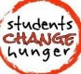 | 20  Spread it Around  Peanut Butter and  Jelly are needed. Organize a food drive. | 21  Garden Abundance  Bring your extra  produce to a local food pantry | 22  Special Donor Reception! | 23  Sweet Savings  Pass up dessert and  donate the savings to Fulfill.
24  Thank a Chef  Say “thanks” to the  generous chefs who donated to the Culinary Classic by dining out | 25  Join us for the 26th annual Culinary Classic at Doolan’s in Spring Lake | 26  Follow us on snapchat:  fulfillnj | 27  Feed a Family  Donate 30 non-  perishable food items to Fulfill. | 28  Take a selfie balancing a spoon on your nose and hashtag it #Spoontember. Be sure to challenge three friends by tagging them in your post! | 29  Become a Donor– Learn more! | 30  Join us on October 14 for Childhood Hunger Day!

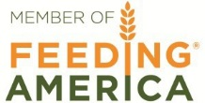
The FoodBank of Monmouth and Ocean Counties is now FULFILL
3300 Route 66, Neptune, NJ 07753

