VITA Screening Tool
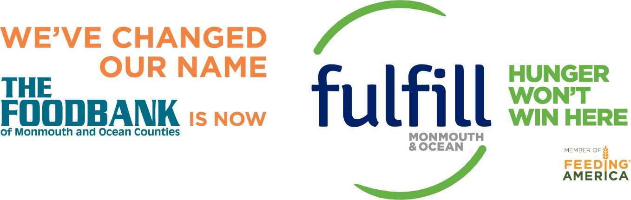

www.fulfillnj.org
Resource Line 732-643-5888
Tax@fulfillnj.org

PART 1: First, see if you qualify for the VITA program:

Yes___ No___ Is your income above $57,000?
Yes___ No___ Are you a resident of a state other than New Jersey, or were you a part-year New Jersey resident last year?
Do you have?
Yes___ No___ Income from rental property?
Yes___ No___ Income from royalties?
Yes___ No___ Property that was bought or sold last year?
Yes___ No___ Casualty losses?
Yes___ No___ Business loss?
Yes___ No___ Cancellation of debt? Tax Forms 1099 C (Ask SC for details)
Yes___ No___ Capital gains income from stocks and bonds?
Yes___ No___ Self-employment income with expenses that exceed $5,000?
Yes___ No___ A deduction/contribution from HSA? Tax Forms 1099-SA or 5498-SA

*If you answered YES to any of the above questions, unfortunately you are outside the parameters of our program and we cannot prepare your tax return.

I am also interested in learning about ___ Budgeting/ Saving/ Debt help, or applying for ___SNAP or ___Health Insurance and agree to be contacted by Fulfill at Tel/ email:_________________________________
- Please note that we can only file taxes for the current tax year (earlier years can be done by appointment)
- You must have a social security card/ITIN (or copy of previous year’s tax return) and birth dates for the filer(s) and any dependents claimed. Photo ID required for filer(s).

PART 2: If you qualify, please answer these additional questions

Yes___ No___ Can anyone (parents, others) claim you on their tax return?
Yes___ No___ Do you have an identity theft Pin? _______________
Yes___ No___ Do you pay mortgage Interest (form 1098T)?
Yes___ No___ Do you pay real estate taxes? If yes, how much last year? ____ Block#_____ Lot#_____
Yes___ No___ Do you rent? If yes: Monthly rent $ _____Yearly Rent $_____
Yes___ No___ Do you receive alimony? If yes, how much annually? $_______
Yes___ No___ Do you pay alimony? If yes: How much annually? $_______
Yes___ No___ Are you married filing separately? If ye, ex-spouse’s social security # ________________

*Yes___ No___ Do you have child or dependent care expenses such as daycare?

Provider Name____________________________Address___________________________
SSN or EIN ______________________ Qualified expenses __________________________
*Yes___ No___ Last year, did you have health coverage for you, your spouse, and all qualifying dependents? If Yes, last year, did you or your spouse receive an advance payment from the marketplace to help you pay for your health care (form 1095-A)? Yes___ No___

*Yes___ No___ Did you have medical expenses? If yes:

Medical/Dental Premiums $__________
Doctor/Dental Costs $_____________
Prescriptions $____________________
X-rays/Lab Work $_________________
Medical Aids/Glasses $____________
Medical Mileage__________________
Hospital Care $ ___________________

*Most premiums are paid with pre-tax dollars, which means they are deducted from your wages by your employer before taxes are applied. In this case, you cannot deduct them here, so fill in $0 if premiums are paid with pre-tax dollars. You can only deduct the premiums if your employer included them in Box 1 (Gross Wages) of your W-2, or if you paid them out of pocket yourself.

*Yes___ No___ Did you give gifts to charity? If yes:
Cash $_________ Non-cash donations $____________ (thrift value)

*Yes___ No___ Did you have qualified education expenses? If yes:
*Tuition costs (1098T) $_________________*Qualified books $_____________
*Other supplies $__________________*Equipment if required by school $___________

*Yes___ No___ Do you have self-employment income or job expenses not reimbursed by your employer? If yes:
*Cash Income ___________________________
*Misc. Income (1099MISC) Box 7 $__________________________
*Business miles_______________
*Tolls $______________________
*Supplies $__________________
*Office Expense $_______________________
*Professional Certifications/Licenses $______________________________
Other $_______________________________

Taxpayer chose: E-File Direct Deposit

Check/ Mailed

If you want direct deposit, please fill out:
Routing Number _________________________
Account Number_________________________
Bank Name _________________________
Checking___ Savings ___

Taxpayer chose: Paper File

*If paper filing was chosen, it is the Taxpayer’s responsibility to mail both Federal and State returns.
Paper File Mailing Address:
*Federal 1040 with Refund: Department of the Treasury Internal Revenue Service Center
Kansas City, MO 64999-0099.
*State of New Jersey with Refund: Division of Taxation Revenue Processing Center-Refunds
P.O BOX 555 Trenton, NJ 08647

I authorize the release of my personal information to a representative of Fulfill, for the purpose of entering my information into Oasis Insight, a secure online database, used only by Fulfill for purposes of providing services or reporting group data to donors. No identifying information will be shared with other agencies without my permission. This Release of Information will remain in effect for 3 years from the date below, unless I make a written request to Fulfill that I no longer wish to participate in Oasis Insight.
I declare, under penalty of perjury, that the information stated above is true to the best of my knowledge, and I am responsible for its accuracy.

Taxpayer Signature_____________________________________ Date: ___________________

Taxpayer Name _______________________________________

